
OFFICIAL QUOTATION

Date: 29/03/2026
Quotation No.: Q-290326-000
Project: Full Decking System Installation
To: MR MALCOLM GIHENO

Scope of Works
Supply and installation of full timber decking system around the house (Walkway) and backyard (Total Area ~149 m²).
Below is the Artistic impression of the basic layout of the proposed structure.
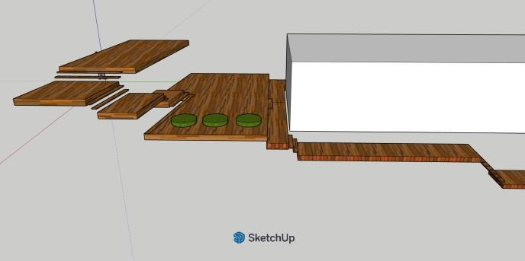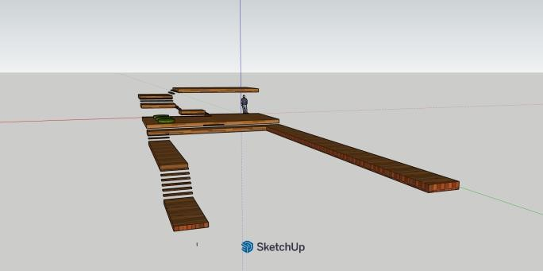

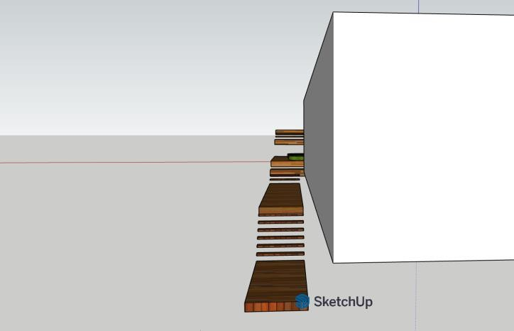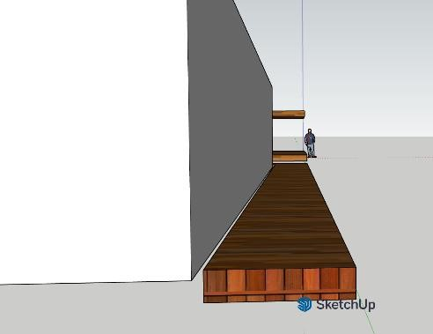

Cost Breakdown
Description |  |  | Qty | Cost (K) | Total amount  (K)
Materials | Posts & Bearers (75mm x 75mm x 6m SHS) |  | 62 pcs | 10,675.00 | 35,103.72
 | Cement (40kg) |  | 18 bags | 540.00
 | Deformed Bar (12mm x 6m) |  | 3 pcs | 66.00
 | Sand / Gravel Aggregate |  | 3 cubic meters | 750.00
 | Joists (50mm x 50mm x 6m  RHS) |  | 13 pcs | 930.00
 | Railing | 50mmx50mm  SHS | 3 pcs | 214.50
 |  | 25mmx50mm  SHS | 5 pcs | 180.00
 |  | 25mmx25mm  SHS | 45 pcs | 773.22
 | Decking Timber (100mm x  25mm x 3.9m) |  | 443 pcs | 15,614.00
 | Decking paint (4L) |  | 10 pcs | 1,700.00
 | Metal Primer (5L) |  | 1 pcs | 400.00
 | Framing paint |  | 3 pcs | 1,650.00
 | Step Brackets 25mmx25mm |  | 6 pcs | 111.00
 | Consumables (Screws, Welding rods etc…) – Lump sum |  | 1 lot | 1,500.00
Labor | Lead Carpenter |  | 1 | 3,000.00 | 8,000.00
 | Carpenter / Welder |  | 2 | 2,600.00
 | General Laborers |  | 4 | 2,400.00
Transport |  |  |  | 1,000.00 | 2,100.00
Admin and Management |  |  |  | 700.00
Contingency |  |  |  | 400.00
Subtotal |  |  |  |  | 45,203.72
Grand Total (+GST) |  |  |  |  | 49,724.12


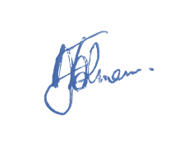
Kind regards,
……………………..
MR Michael Jalmein – Operations Manager
RABALLAM MAINTENANCE LTD

